**Software Requirement Engineering**



**Submitted To**

Ma’am Farah Adeeba

**Submitted By**

Iman Fatima 2021-SE-10

Wali Muhammad 2021-SE-39

Khadeeja 2021-SE-53

**ONLINE COMPUTER SHOPPING SYSTEM**

**Department of Computer Science**

**University of Engineering and Technology (New Campus),**

**Lahore.**

**TABLE OF CONTENTS:**

1. VISION STATEMENT
2. STAKEHOLDERS
3. REQUIREMENT ELICITATION TECHNIQUES

3.1. INTERVIEW

3.2. SURVEY

3.3. QUESTIONAIRES

**VISION OF PRODUCT**

**For** those Customers **who** want to buy Computer according to their requirement, **the** Online Computer Shopping System **is** an online retailer website that offers customer a comprehensive selection of the components to build their PC, accepts online orders, generate and store order report and provide delivery service to Customers. **Unlike** other products, **our product** will assist customers who don’t have knowledge to select right components to build PC. It will also provide recommended PC builds according to user’s requirement in specific budget range. This will save both customers precious time and money.

**STAKEHOLDERS:**

* Shop Owner and IT Manager
* Customers
* Couriers

**REQUIREMENT ELICITATION TECHNIQUES**

**INTERVIEW**

|  |  |
| --- | --- |
| Name of Interviewer | Wali Muhammad |
| Number of Interviewee | 1 |
| Date of Capturing Requirement | 25-12-2022 |

# **Stakeholder Information:**

|  |  |
| --- | --- |
| **Stakeholder Position/Role** | Shop Owner and IT Manager |
| **Stakeholder Name** | Abdul Samad |
| **Stakeholder Brief Introduction** | Abdul Samad is the owner and manager of AS Tech & Games located at 46a, 2nd Floor Hafeez Center, Gulberg III, Lahore. |

**QUESTIONS**

|  |  |
| --- | --- |
| Introduction | Deals in Computer Builds and Computer accessories. |
| How the current system is working? | Manual work. |
| How the System will work? | System will work online, accepts orders, Generate and Store Invoices and helps user to buy PC according to their budget. |
| What is the major purpose of the system? | Accepts online orders and fulfill users need. Store order details |
| Why a new system? | Biased my old manual work, walk along with new technology and Increase business and profit. (Technical errors in manual work) |
| Any sort of potential pitfalls exists in manual system? | Time is wastage in Manual work, Hard to store older order histories and proper customer guidance issues. |
| How the system will help work? | Generate automatic Invoices of order placed and store order history and accept online order and guide customer |
| Who are the end users of the system? Who are Target customers? | Target customers are computer user (who need to purchase computer (Gamers, Graphic Designers etc.). |
| Which type of users can use website? | Any lay person having basic knowledge about retailer website and computers can use website (Interface must be simple and comprehensive) |
| How the system facilitates the users or how system solves user problems? | Provide custom selection feature according to requirement, guidance & knowledge about computer info. And online delivery services. |
| Which users can visit website? | Anyone can visit website for checking the product attributes, and using custom selection feature. |
| Which users can order online? | Only registered users can order online. |
| What are the inputs required to register a user? | User credentials (Name, email, phone number), credit card(optional) |
| Which rules should be followed by user to visit and place order? | All terms and conditions. |
| Can website protect user from logical injuries including financial losses? | Website should help and guide user to select right computer according to their requirement and it should save customers time and money and if something happened unexpected then it should inform the user. |
| Security feature? | System should be resistive against external attacks and user sensitive information must not be exposed to anyone even admin. |
| What are the expectations of the availability of the system? | 24/7 available. Delivery can be provided only in working hours |
| Is your system fault tolerant? | Yes (if user enter wrong credentials, the system will not respond to crash). |
| What should the system will do if user do unintentional errors? | Display a message that you have enter incorrect information or show error message and details. |
| What is required to visit website or placing an order? | Any device that can open browser (Mobile phones, computers or laptops etc.) and an active internet connection is must to access website and place order online. |
| What should be the response time of your system? | Quick response from webpage. It depends on user’s internet speed. |
| Can different environment and circumstances cause effect on the system? | It should not but if necessary. |
| User interface? | User interface should be easy and comprehensive. |
| Why the users use your system? Which functionality can cause users use your system? | The custom selection feature can provide user facility to select the computer according to their requirement and online delivery service. |
| What are the Expectations from the System? | Increase the sale, low work loaf from IT manager. Automatically respond to user queries |
| What are you Future Goals related to this system? | Use latest tech, Expand business, User Friendliness and Update features. |
| Who can manage the online system and respond to end user? | IT manager. |
| What an IT manager can do? | Can add, delete products and marks the products as out of stock or note available right now. Check order details, invoices and customer feedbacks. In case the issue is not handles by the system the IT Manger can interact with user. |
| Can IT Manager respond to user? | Yes |
| How can IT Manager responds to user? | By providing email and phone number |
| What are the benefits for IT Manager? | Minimize work load, Burdenless, promotion, see order history and check invoices, save time |
| What defines the success of this project? | Increase sales, Increase in Profit |

**Final Statement:**

**Website Name:** AS Tech & Games

**Time Duration:** 1 month

**SURVEY**

**Questions:**

* Enter your name
* Email
* Age
* Top of Form
* Gender
* Profession
* Have you ever used any e-commerce retailer website?
* Is an online computer shopping system better than a manual system?
* Why do you prefer online shopping (choose as many as applicable)?
* What is the biggest challenge you have ever faced in a manual system?
* What features you must want to see in our online shopping system?
* Would you like to search products in a customized range of prices?
* Which type of electronic products you would like to buy?
* What payment options do you prefer on the online store?
* Would you like to get message for your order confirmation?
* Any additional functionality you would like to recommend for our system?

**DATA COLLECTED AS A RESULT OF SURVEY:**

**TOTAL RESPONSES COLLECTED:** 55

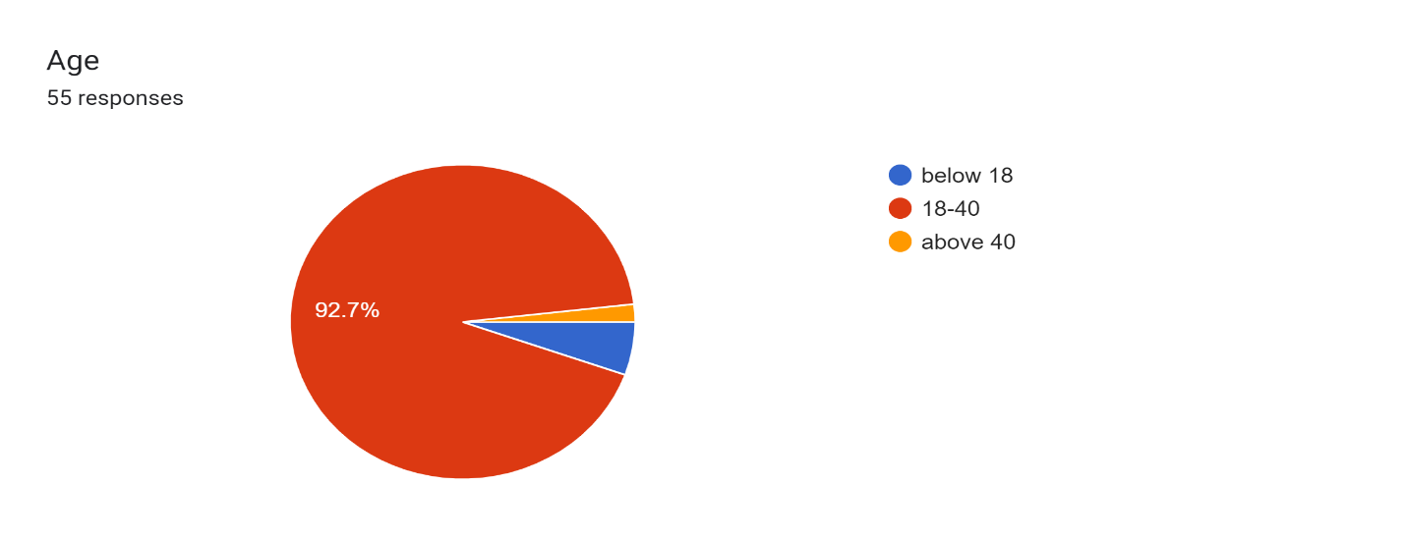

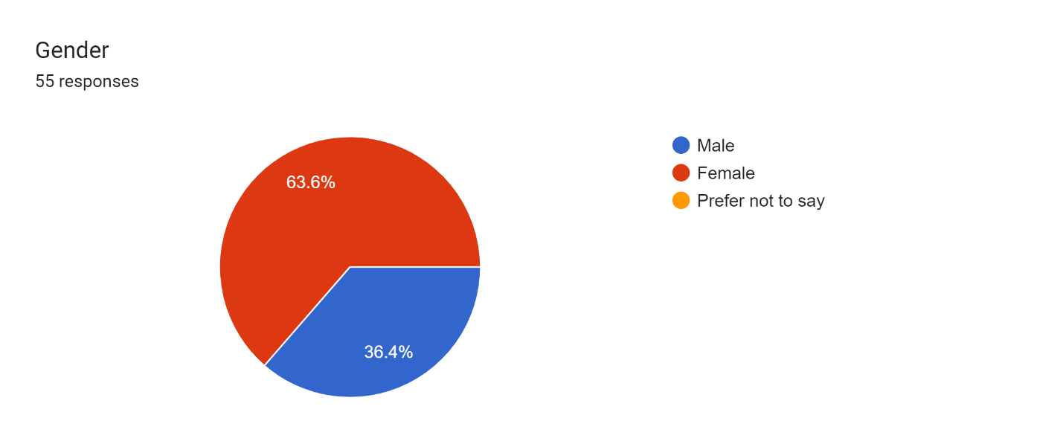

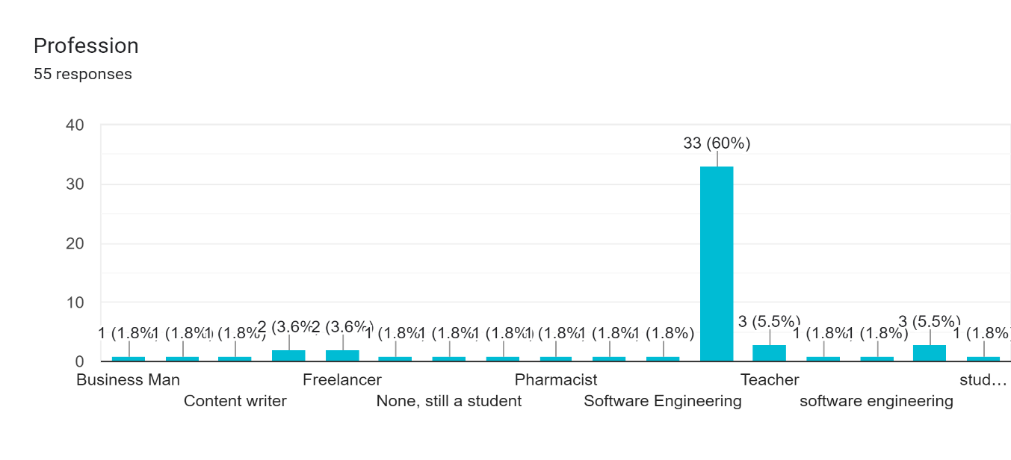

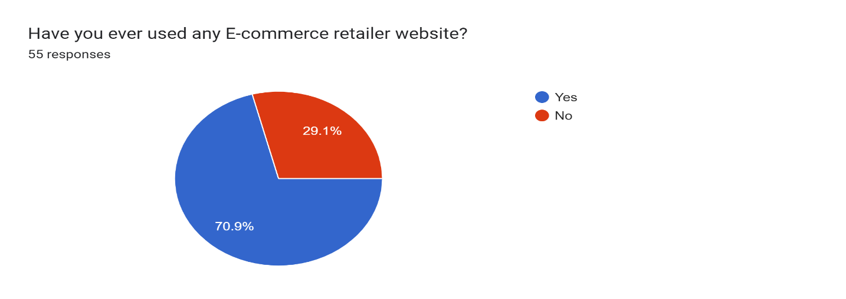

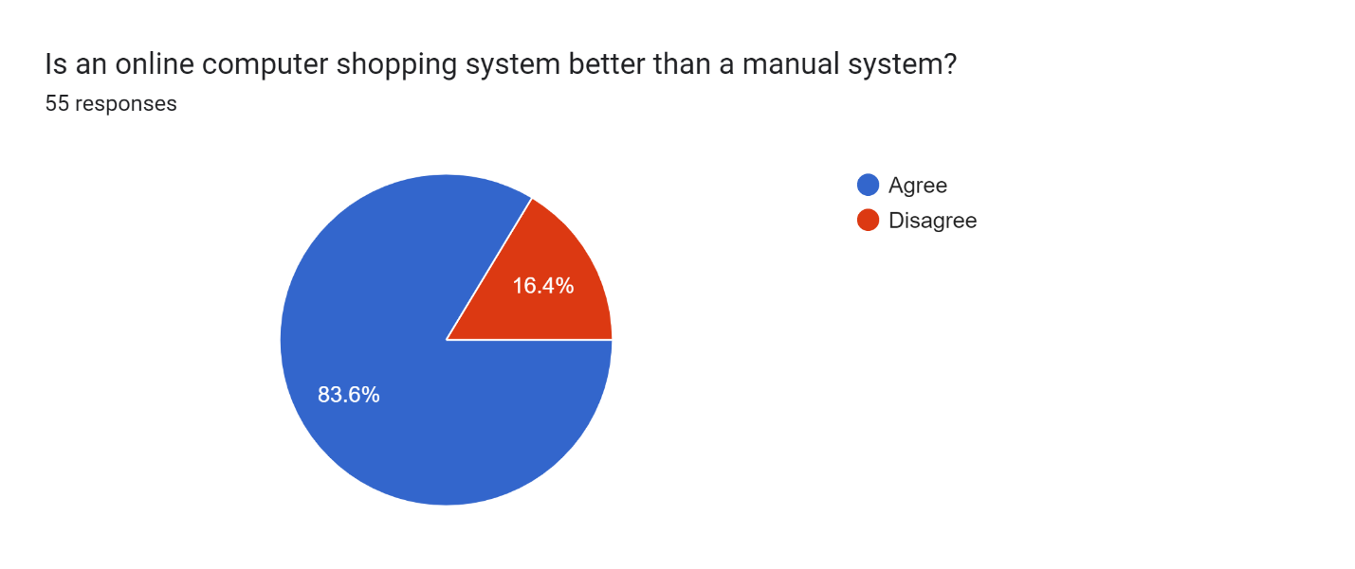

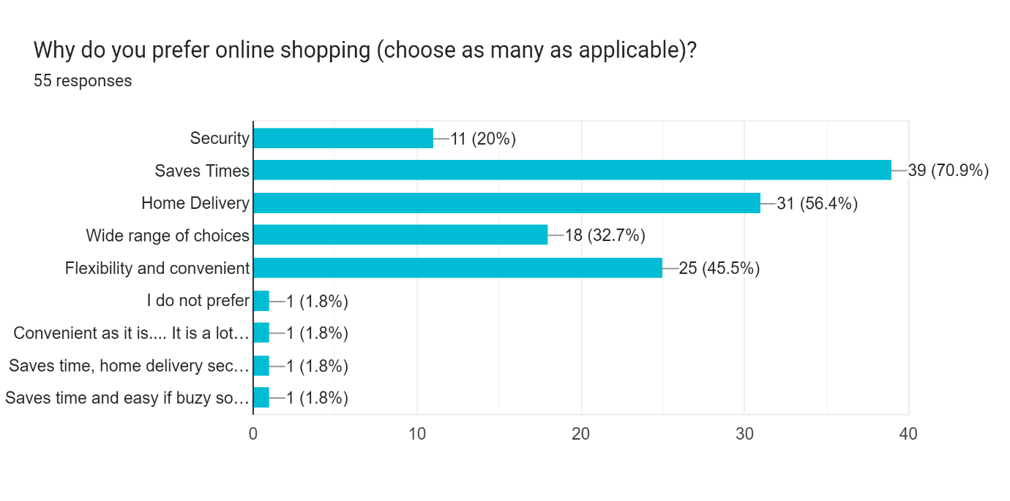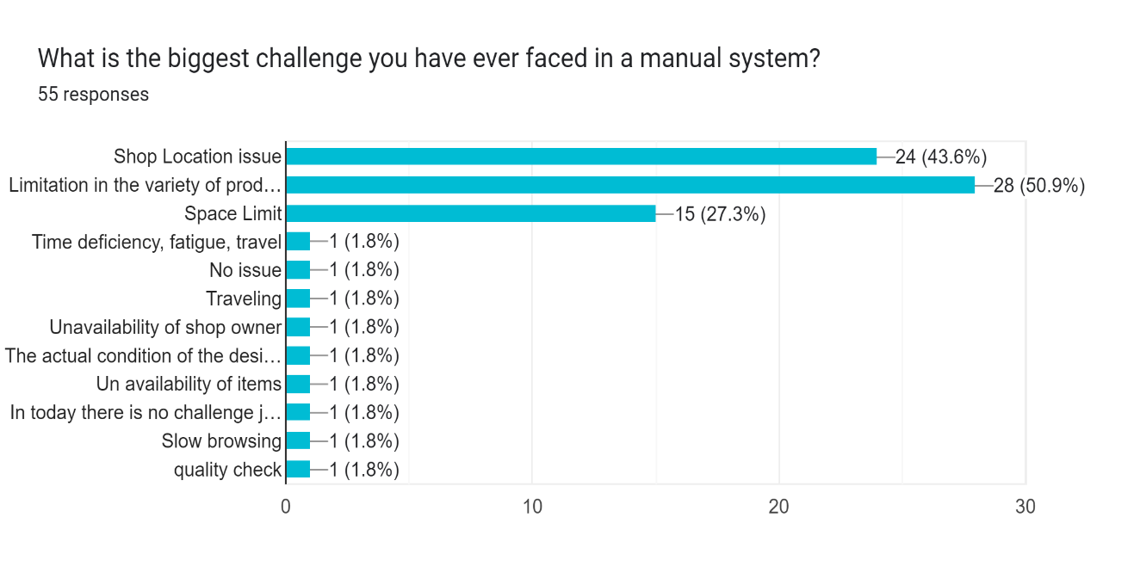

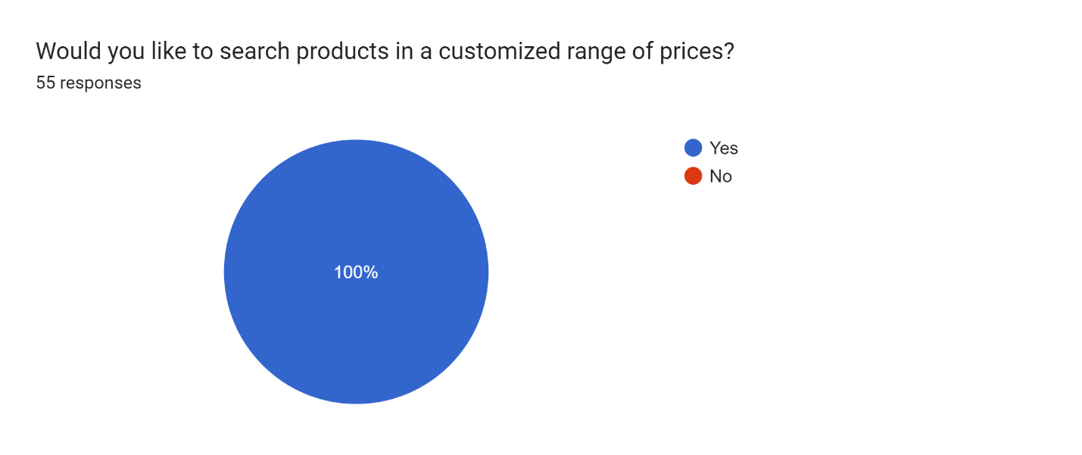

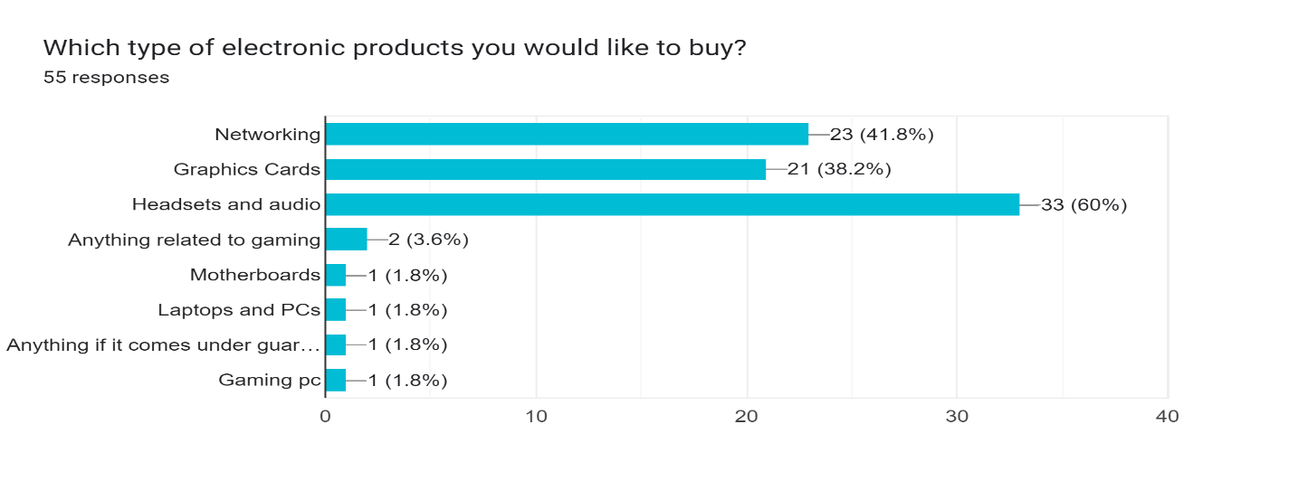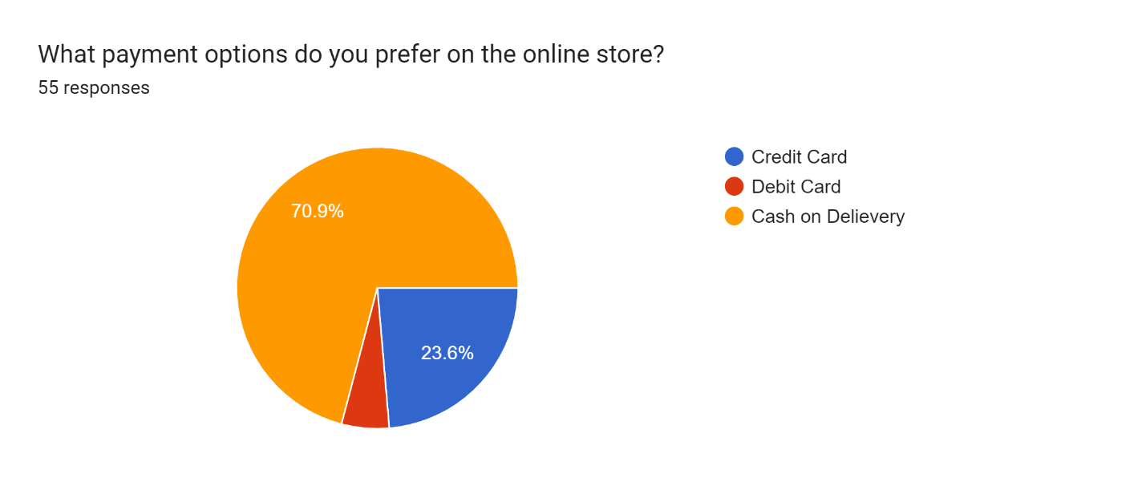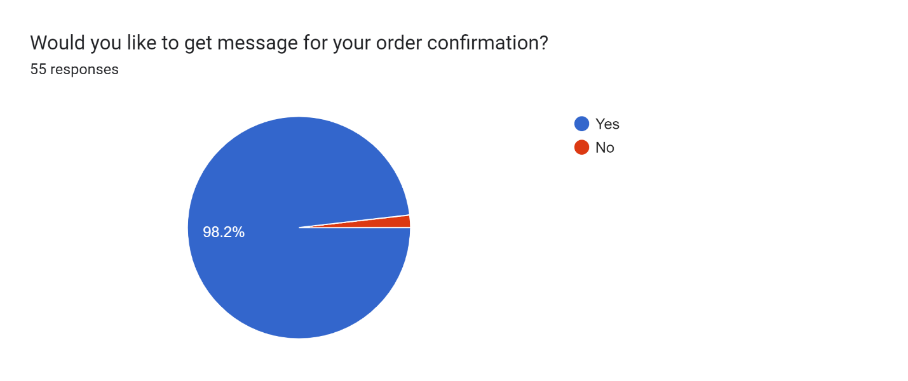

**RECOMMENDATIONS**

* No
* N/A
* Best Customer service along with authentic products
* All good
* Customer reviews about the products must be visible
* Ratings of the retailer
* Customers would be able to cancel their order
* I want if there is comparison already given for selected devices and they properly compare the devices in the terms of Ram, storage, speed, lifetime, price, size and other specifications.
* delivery time
* No thank you
* Return policy
* Ummm just make sure that everything will be well organized. All the best
* The system should provide the best 💻 to their customers
* You should ensure that there is no wrong shipment of electronic goods
* No
* none
* I wanna know where the most rated things are ...
* Gud products must be delivered which we see in online
* Quality must be good
* Do make reviews of products. Do show products availability. Make a feedback option. Make warranty of products.
* Immediate response to the customer
* I think the described system of yours is pretty efficient par to the standards of an online shopping systems. Although I do would recommend to provide extra safety criteria so that customers feel inclined to shop from your system
* I think that it should be more convenient reliable delivery, reliable payment. So most of the people buy online.
* I think online shopping saves time and its a good way for some people who dont socialise much like dont go to markets and they find markets away from there home so its a good way to interact.
* i do not have something to say
* All is enough.

**QUESTIONAIRES FORM COURIER**

* Name
* Gender
* Age
* Any experience as a courier?
* Tell about the delivery experience?
* Give info related to forms
* Are you sure that you deliver parcel in a timely manner?
* What would you do if a customer is unhappy from parcel delivery?
* Tell about a time when you will work with a team?
* How do you organize and plan deliveries?
* What would you do if you trap in traffic?
* How would you improve your delivery process?

**TOTAL RESPONSES COLLECTED:** 10